**Project Stage 2 ER diagram**

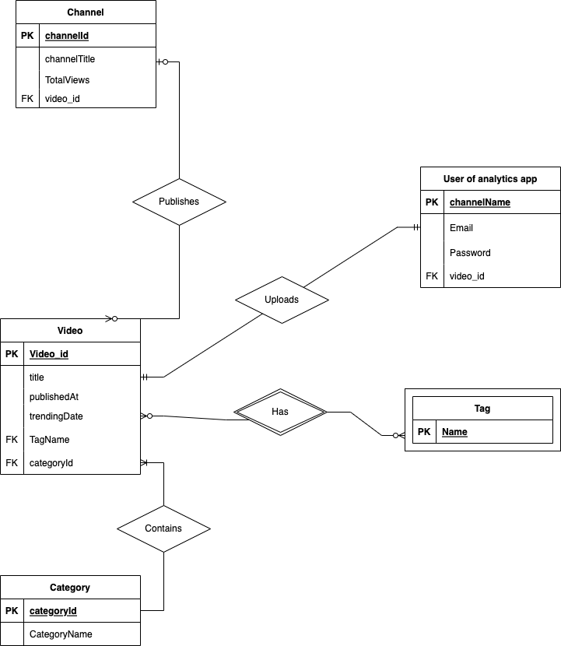

**Description of Assumptions:**

The video entity contains a private key called video_id and also contains other attributes such as title, publishedAt, trendingDate. Video is the entity with the most relations. For the video to category relationship, we assume that every video can have a maximum of one category but every category can have multiple videos. Category entity has categoryId as its private key.

For video to tags relationship, we assume that every video can have 0 to multiple tags as well as every tag can have 0 to multiple videos.

The tag just has the private key variable Name as its key.

The user of analytics app entity has one private key channel name and other attributes such as email, password for login to the web app. It also has a foreign key to the video entity.

For user of analytics entity, we assume the every video that the user inputs is related to only one video in the video entity.

The channel entity has its private key as channelId with other attributes such as channel title, total views of the channel. It also has a foreign key to the videos entity.

For the channel to video entity, we assume a channel can have 0 to many videos so it is a 1 to many relationship.

**Relational Schema**

Channel(channelId: INT [PK], channelTitle: VARCHAR(255), video_id: INT [FK to Video])

User(channelName: VARCHAR(255) [PK], Email: VARCHAR(255), Password, video_id: INT [FK to Video])

Video(Video_id: INT [PK], title: VARCHAR(255), pulishedAt: DATETIME, trendingDate: DATETIME, TagName: VARCHAR(255) [FK to Tag], categoryId: INT [FK to Category])

Tag(Name: VARCHAR(255)[PK])

Category(categoryId: INT[PK], categoryName: VARCHAR(255))